Linkedin
1. Look at the Linkedin profiles. What do you think? Where does he/she work? Is he/she a professional???
a)
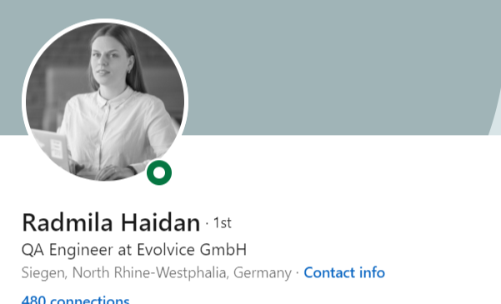

b)
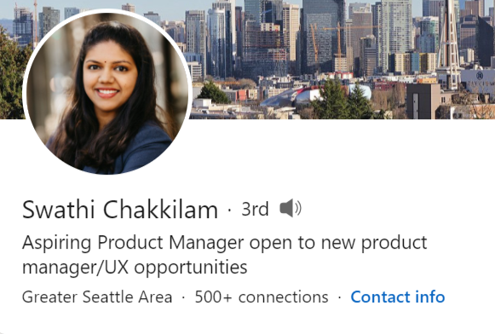

c)
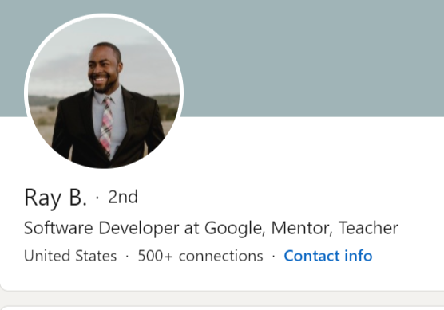

2. Match the profile with the “About” section.
1. Radmila
2. Swathi
3. Ray
a)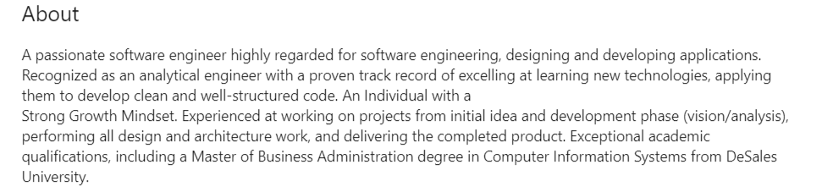
b)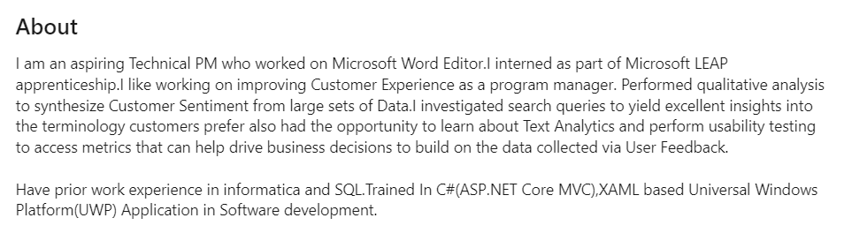
c)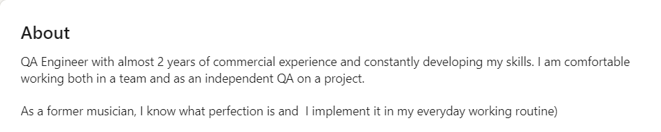

3. Look at the highlighted words in the summary. Are they about the Past, Present, or Future?
“I am an aspiring Technical PM who worked on Microsoft Word Editor. I interned as part of the Microsoft LEAP apprenticeship. I like working on improving Customer Experience as a program manager. Performed qualitative analysis to synthesize Customer Sentiment from large sets of Data. I investigated search queries to yield excellent insights into the terminology customers prefer also had the opportunity to learn about Text Analytics and perform usability testing to access metrics that can help drive business decisions to build on the data collected via User Feedback.
Find 2 more words about the past.

Grammar Note
The simple past tense shows that you are talking about something that happened.
I worked here in 2009.
I was happy to see him.
They were a good team.
For irregular verbs, you need to check the table or Google.
I read this book last month.
She bought me a cup of coffee.
Past simple – verb 'to be'
I was, You were, she/he/it - was, They were, We were
We can use the past simple of the verb to be to talk about situations and states in the past.
I was at the office yesterday.
They were happy with the project.

4. Fill in the table with the missing sentences.

+ | - | ?
I worked at Microsoft | I did not work at Microsoft | Did I work at Microsoft?
 | I wasn’t his manager | Was I his manager?
She studied at Harvard |  | Did she study at Harvard?
 | He did not finish this course
We worked together at Google
She was a QA 5 years ago. |  | Was she a QA 5 years ago?
They were part of a big team | They were not part of a big team.

5. Divide the verbs in the box into 3 columns. Use the past form of these verbs.

- to work
- to lead
- to participate
- to complete
- to develop
- to manage
- to organize
- to be in charge of
- to accomplish
- to mentor
- to take part

Words to show experience | Words to show achievements | Words to show leadership
ex. worked

6. Answer the questions about yourself (write). Use verbs from the ex.6
What tasks and responsibilities did you have at your last job (before this one)?
What achievements did you have?

7. What are the 3 key factors for your Linkedin profile?
Generate some ideas.
8. Watch the video and check your answers. Can you think of some other important things for a Linkedin profile?
How to Make a Great Linkedin Profile - TIPS + EXAMPLES

9. Put the missing words into the sentences.
- Linkedin is where the ....... is.
2) This picture could work on Instagram but it's not really ...... for Linkedin.
3) Now think of the ...... that people would use to find you and incorporate those in your title.
4) That's something that surprises people, that could be a............ starter, that explains a little bit more what you stand for.
5) The ........is the piece of text that you can find below your title.
Watch again and check your answers

10. Read the tips. What do you think each of them means?

- 1. Put in the Time to Make it Awesome

- 2. Get a Custom URL

- 3. Choose a Great Photo

- 4. Write a Headline That Rocks

- 5. Highlight your skills

- 6. Don’t Waste the Summary Space

- 7. Use Numbers Right Up Front

- 8. Avoid Buzzwords

- 9. Treat Your Profile Like Your Resume

- 10. But Use the First Person

11. Check which tips did Bruce use for his profile. (You might have to find his profile to check tip #2)
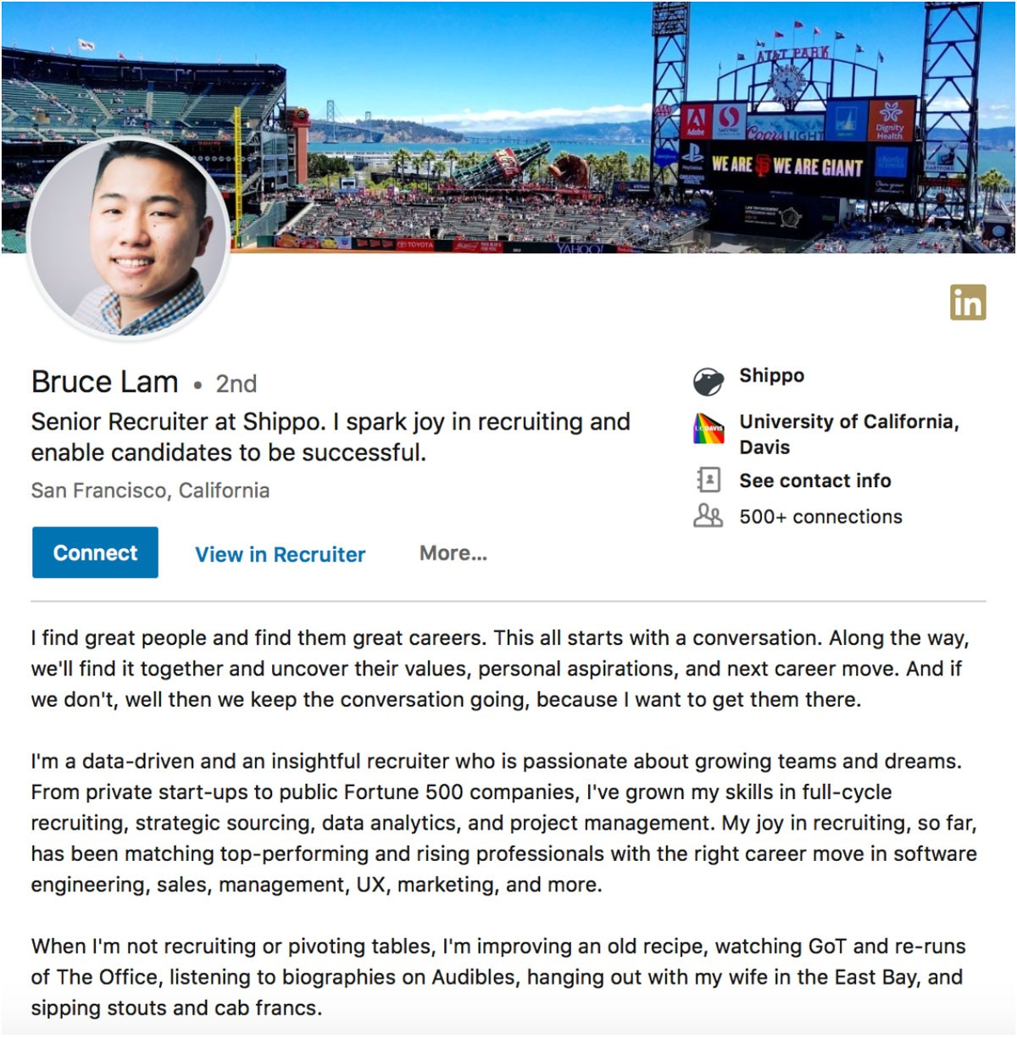

Bonus!!
Linkedin Buzzwords (Try not to overuse them).
- Specialized
- Experienced
- Leadership
- Skilled
- Passionate
- Expert
- Motivated
- Creative
- Strategic
- Successful

